|  |  |
| --- | --- |
| Course Name | ITD 2313 – Script Programming |
| Instructor | Put instruction name here |
| Student Name | Put student name here |
| Due date | Put assignment due date here |
| Grade | Put grade earned here |
| Grading Comments | Put instructor comments here |

### Page 136

1. There are 5 small sets of code example blocks on this page.  The first is about 1/4 way down and starts with Import math.
2. The second code example block is about 1/2 way down and starts with first=.
3. The third code example block is just a few lines later and starts with third=.
4. The fourth code example block starts with the len function.
5. The last one is at the bottom of the page and completed on this page.

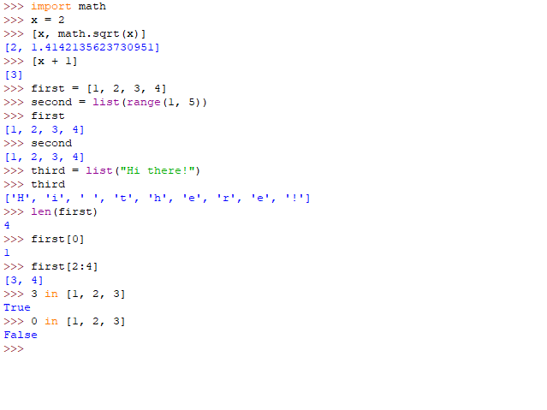

### Page 137

1. The first code example block on this page will be the one that starts print.
2. The second code example block is the one that covers the for loop.
3. The third and final code example block on this page deals with the in operator.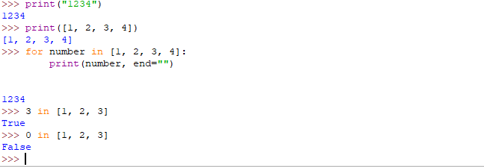

### Page 138

1. There are three code example blocks on this page, the first being about 1/4 the way down on the page.
2. The second code example block is 1/2 way down.
3. The last code example block on the page is 3/4 the way down on the page.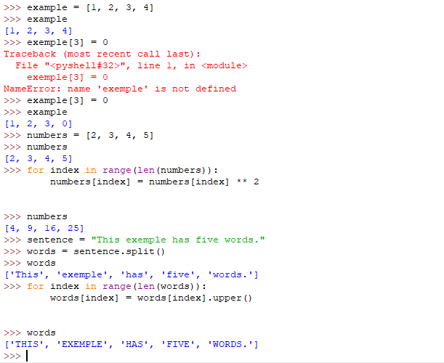

### Page 139

1. There are two code example blocks on this page, the first is 1/2 way down.
2. The last code example block is on the bottom of the page and does complete on the page.

### Page 140

1. The first code example block is about 1/4 the way down.
2. The second code example block is actually in the next section on that page for searching.  It does not show output.  You will need to show the output of that searching code.

### Page 141

1. The first code example block is near the top of the page.
2. The last code example block is on the bottom of the page but it is included on the next set of instructions as it ends on the next page.  So just the one screen shot here on this page. 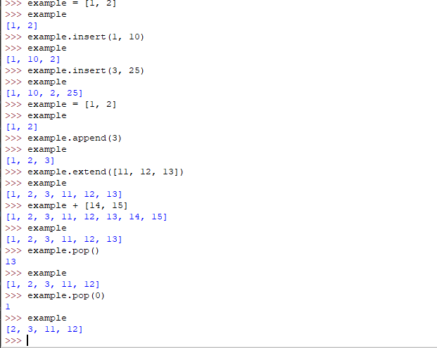

### Page  142

1. The code example block that is at the top of this page begins on the previous page. Put the screen shot of the whole set here under this set of instructions.
2. About 1/2 way down is the second and final code example block on this page.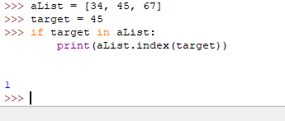

### Page 143

1. There is a small code example block of a single line at the top.  There is not output given but you will need to execute and catch the output in your screen shot.
2. The next code example block is about 1/2 way down and is in the  next subsection and will be on this page of screen shots.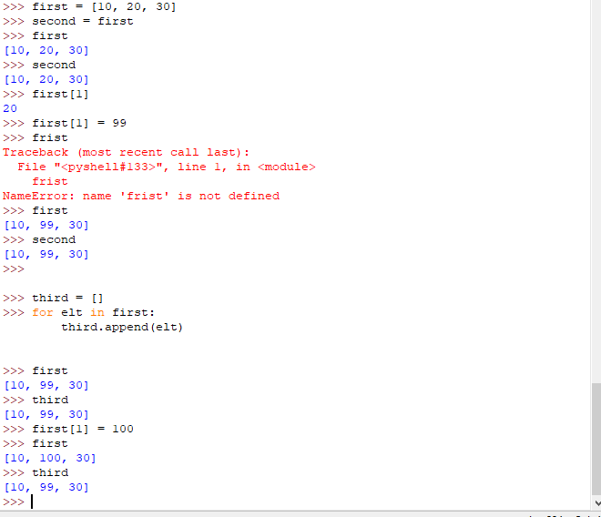

### Page 144

1. The first code example block is actually a script that is available in the download for this chapter.  Load it in and run it to get the screen shot.
2. The second code example block on this page actually ends on the next page and should be included on that page's instructions set.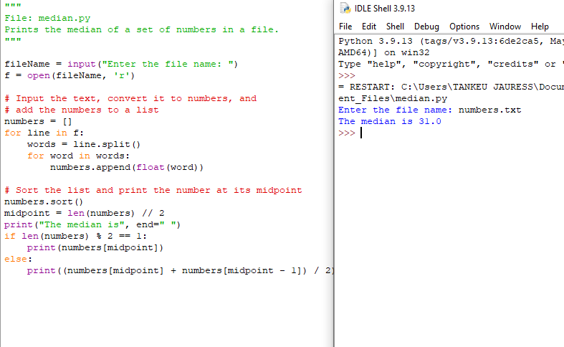

### Page 145

1. The first code example block on this page starts on the previous page. The screen shot for entire code block should be on this page.
2. The second code example block is about 1/2 day and just before the exercises portion on the page.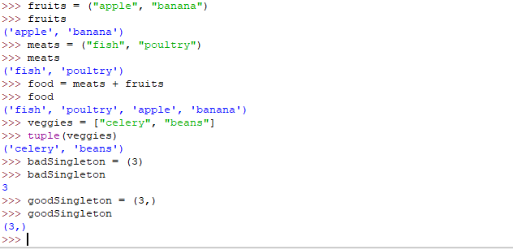

### Page 146

1. You will need to do the small code example block at the very bottom of the page before doing the few lines above it.  This last code example block on the page defines the function that is used in those previous lines.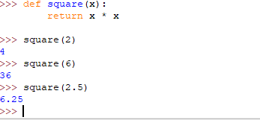

### Page 147

1. The code example block in the middle of the page is similar to the one on the previous page in that the function needs to be typed in first and then the line above it so it will execute correctly.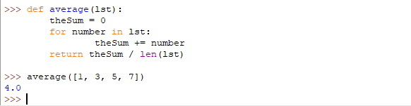

### Page 148

1. The code example block in the middle of this page also has that function example after the lines that use it.  So you will need to type in the function items first and then do the examples using the function.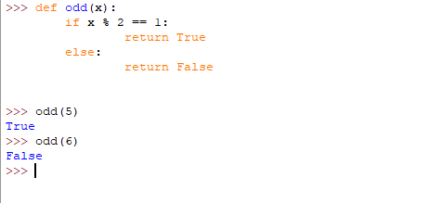

### Page 149

1. You may find that the code example block is easier to implement with a script than in the interactive shell.  So put this code example block into a script and then execute it, catching the screen shot after implementation.

The Case study Generating Sentences is not one you need to catch screen shots of but you should go through it and use it as a learning tool.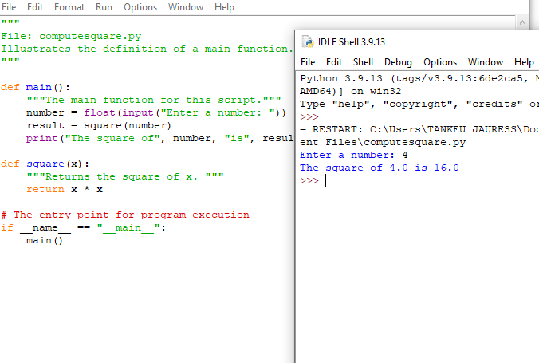

### Page 154

1. In the middle of the page, there is code example block of a few lines and then another line after some text.  They are all together 1 block and you can include them all into a single screen shot.
2. There is a small code example block at the end of the page.  It shows an error condition. Grab a screen shot of the error you get.  The code ends on the page also.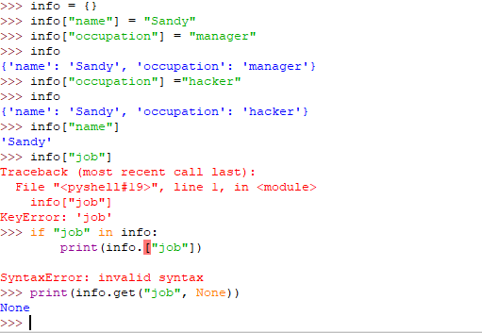

### Page 155

1. There are two small code example blocks at the top of the page.  Both can be placed into a single screen shot.
2. In the middle of the page, there is a code example block about removing keys.
3. In the subection on Traversing a Dictionary, the last code example blocks are at the bottom of the page and can be grouped into a single screen shot if you would like.  The code does end at the end of the page too.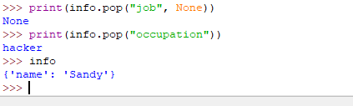

### Page 156

1. There is a small code example block about 1/4 the way down that page.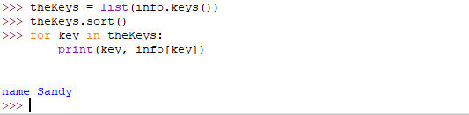

### Page 157

1. The code example blocks here form a series of items that are interrelated.  You may find this also is easier to do in a script instead of interactive.  If you do go the way of a script, be sure to run it and capture the output.
2. The code example block at the end of the page is finished on the next page so include that on the next page instruction set.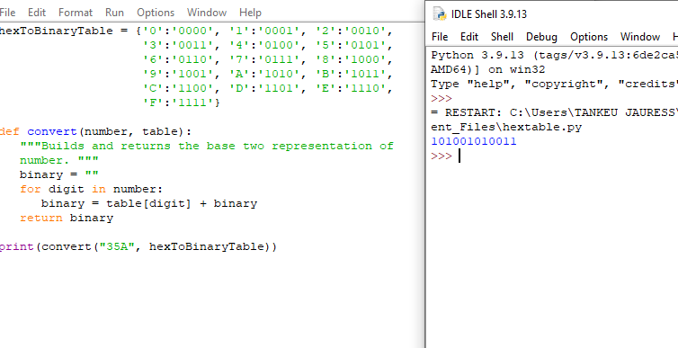

### Page 158

1. The code example block at the top of the page is started on the previous page.  Finish it up on this one and capture the screen shots as needed.  This one too may be one you prefer to do in a script instead of the interactive mode.

